Name: ______________________ Block: ____

Word Stem Practice – 1-30
Directions: Using your knowledge of word stems, determine the example word that best fits the definition.
aquifer darkness
supervise triangle
fiction pretest
transport antibacterial
misbehave submarine
bicycle reliable
massive united
symphony supervise
telephone biology
astrologist autograph
unusual geography
hemisphere
Word Bank
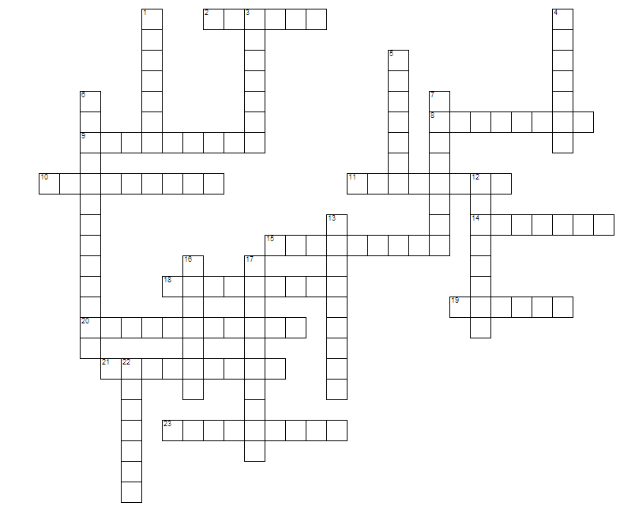
Across
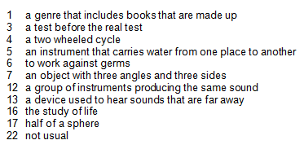
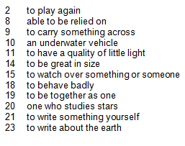
Down
Directions: Use your understanding of stems to complete the chart below. Use your planner or a dictionary to help you. Make sure the example words are spelled correctly.
 | STEM | DEFINITION | EXAMPLE WORD
 | auto
 |  | make
 |  |  | prefix
 | anti
 |  |  | reliable
 |  | voice
 |  |  | massive
 | logy
 |  | earth
 | hemi
 |  | write
 |  |  | triplets
 | uni
 |  | one who
 | tele
 |  |  | misbehave
 |  | sound
 |  |  | subway
 |  | over
 | fer

